Programming Fundamentals Lab 11
Rana Muhammad Hussain
25K-0141
Task 1 SS:
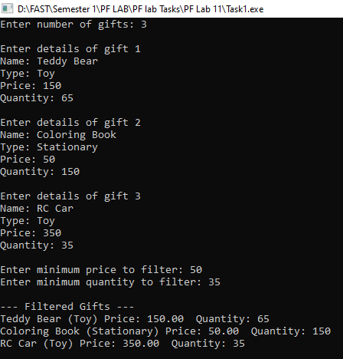

Task 2 SS:
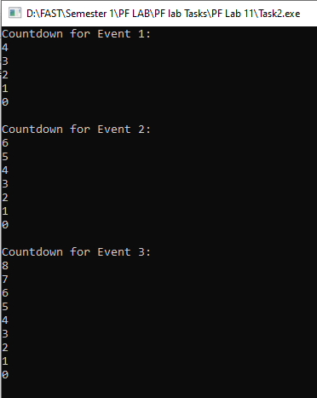
Task 3 SS:
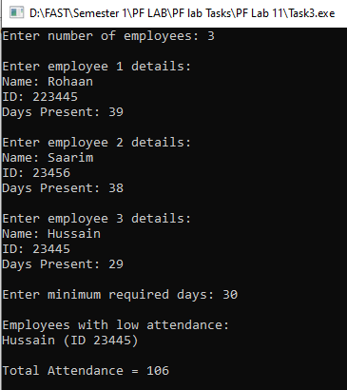
Task 4 SS:
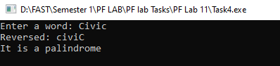
Task 5 SS:
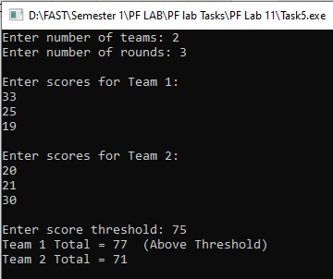
Task 6 SS:
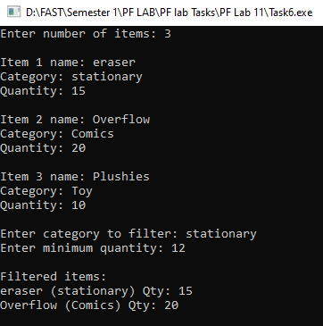
Task 7 SS:
